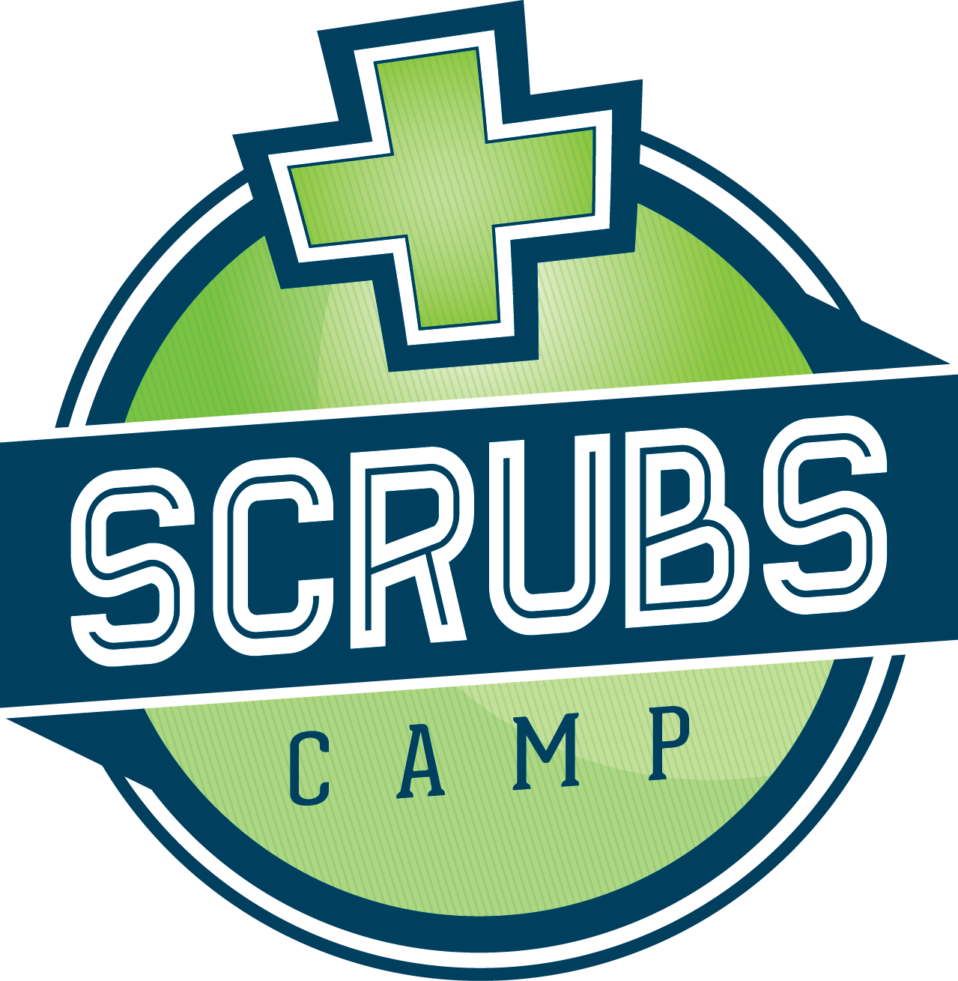

PSA

Area high school students will have an opportunity to explore a variety of health career options during Scrubs Camp sponsored by *(insert hosting facility)* on *(insert date)* at *(insert location)*. Scrubs Camps are one-day learning experiences conducted throughout the state. Students will hear from healthcare professionals about their career and the healthcare industry. They will also be able to participate in exciting hands-on activities and receive personalized career guidance.

Scrubs Camps are designed for high school students from grades 9 through 12 with an interest in the healthcare field. There is no charge to attend. Parents are also welcome to attend the camp with their child. Pre-registration for the camp is necessary and can be done through the camp coordinator. To find a camp coordinator near you, visit <https://doh.sd.gov/programs/scrubs-camp/>.

For more information contact (*insert local contact name and phone number).*