Points of Dispensing Social Media Promotion
How partners can help spread the word
Create your own posts, using the sample social media copy below. Copy and paste the image in photo/copy and paste content in text.
Make sure you tag South Dakota Department of Health Facebook (@SDDOH) “X” (@SDDOH) and LinkedIn (@SDDOH) handles.
 | EDUCATION
 | Twitter | Facebook /LinkedIn | IMAGE
 | ARE YOU PREPARED?  Points of Dispensing (POD) sites protect communities during a healthcare emergency. To learn more about PODs and preparedness visit the South Dakota Department of Health at https://doh.sd.gov/health-care-professionals/public-health-preparedness-and-response/Points-of-dispensing-information-resources/.  #PreparedCommunity | ARE YOU PREPARED?  Points of Dispensing (POD) sites throughout the state protect communities during a healthcare emergency involving a disease outbreak or bioterror attack. Yankton POD Volunteer, Erin Hacecky, states, “PODs are important to deliver countermeasures when whole communities are affected by an exposure.” To learn more about PODs visit the South Dakota Department of Health at https://doh.sd.gov/health-care-professionals/public-health-preparedness-and-response/Points-of-dispensing-information-resources/.  #PreparedCommunity | 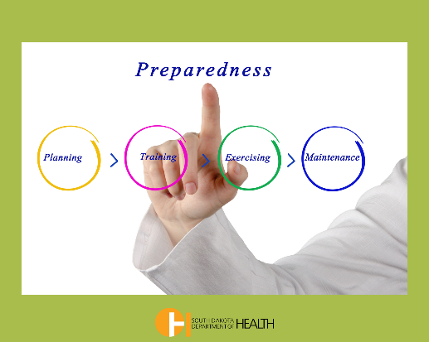
 | ARE YOU PREPARED?  Points of Dispensing (POD) sites protect communities during a healthcare emergency. To learn more about PODs and preparedness visit the South Dakota Department of Health at https://doh.sd.gov/health-care-professionals/public-health-preparedness-and-response/Points-of-dispensing-information-resources/.  #PreparedCommunity | ARE YOU PREPARED?  Points of Dispensing (POD) sites throughout the state protect communities during a healthcare emergency involving a disease outbreak or bioterror attack. Yankton POD Volunteer, Erin Hacecky, believes, “PODs are important to deliver countermeasures when whole communities are affected by an exposure.” To learn more about PODs visit the South Dakota Department of Health at https://doh.sd.gov/health-care-professionals/public-health-preparedness-and-response/Points-of-dispensing-information-resources/.  #PreparedCommunity | 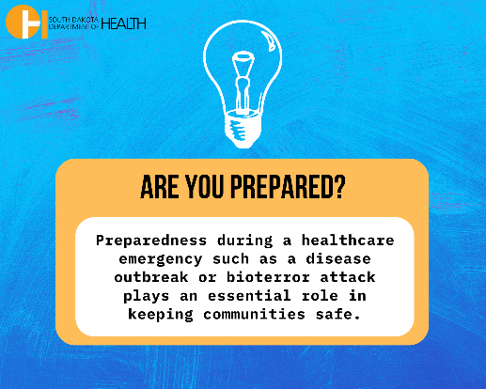
EDUCATION
Twitter |  | Facebook /LinkedIn | IMAGE
DID YOU KNOW?  Points of Dispensing (POD) sites save lives during a healthcare crisis. For more information and education about PODs visit the South Dakota Department of Health at https://doh.sd.gov/health-care-professionals/public-health-preparedness-and-response/Points-of-dispensing-information-resources/.  #EmergencyPreparedness |  | DID YOU KNOW?  Points of Dispensing (POD) sites located throughout the state provide communities with medications during a healthcare crisis such as a disease outbreak or bioterror attack. Mitchell POD Volunteer, David Beintema, says it is “Important to keep volunteers engaged, active and trained. POD training is important to evaluate what works and where improvements need to be made.”  For more information and education about PODs visit the South Dakota Department of Health at https://doh.sd.gov/health-care-professionals/public-health-preparedness-and-response/Points-of-dispensing-information-resources/.  #EmergencyPreparedness | 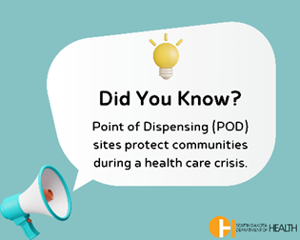
DID YOU KNOW?  Points of Dispensing (POD) sites save lives during a healthcare crisis. For more information and education about PODs visit the South Dakota Department of Health at https://doh.sd.gov/health-care-professionals/public-health-preparedness-and-response/Points-of-dispensing-information-resources/.  #EmergencyPreparedness |  | DID YOU KNOW?  Points of Dispensing (POD) sites located throughout the state provide communities with medications during a healthcare crisis such as a disease outbreak or bioterror attack. Mitchell POD Volunteer, David Beintema, says it is “Important to keep volunteers engaged, active and trained. POD training is important to evaluate what works and where improvements need to be made.”  For more information and education about PODs visit the South Dakota Department of Health at https://doh.sd.gov/health-care-professionals/public-health-preparedness-and-response/Points-of-dispensing-information-resources/.  #EmergencyPreparedness | 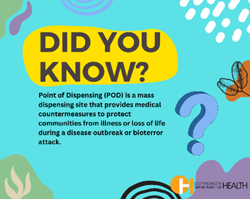

EDUCATION
Twitter | Facebook /LinkedIn | IMAGE
COMMUNITY STRONG  Points of Dispensing (POD) sites protect communities if a healthcare crisis occurs. Community volunteers are strong and prepared during a crisis.  Learn about PODs at https://doh.sd.gov/health-care-professionals/public-health-preparedness-and-response/Points-of-dispensing-information-resources/.  Volunteer today at https://volunteers.sd.gov/index.php.  #CommunityStrong | COMMUNITY STRONG  Points of Dispensing (POD) sites protect communities if a healthcare crisis such as a disease outbreak or bioterror attack occurs. Community volunteers are prepared during a crisis.  Learn more about PODs at https://doh.sd.gov/health-care-professionals/public-health-preparedness-and-response/Points-of-dispensing-information-resources/.  POD sites need community champions like YOU to volunteer.  Volunteer today at https://volunteers.sd.gov/index.php.  #CommunityStrong | 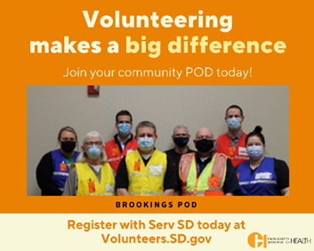
COMMUNITY STRONG  Points of Dispensing (POD) sites protect communities if a healthcare crisis occurs. Community volunteers are strong and prepared during a crisis.  Learn about PODs at https://doh.sd.gov/health-care-professionals/public-health-preparedness-and-response/Points-of-dispensing-information-resources/.  Volunteer today at https://volunteers.sd.gov/index.php.  #CommunityStrong | COMMUNITY STRONG  Points of Dispensing (POD) sites protect communities if a healthcare crisis such as a disease outbreak or bioterror attack occurs. Community volunteers are strong and prepared during a crisis.  Learn more about PODs at https://doh.sd.gov/health-care-professionals/public-health-preparedness-and-response/Points-of-dispensing-information-resources/.  POD sites need community champions like YOU to volunteer.  Volunteer today at https://volunteers.sd.gov/index.php.  #CommunityStrong | 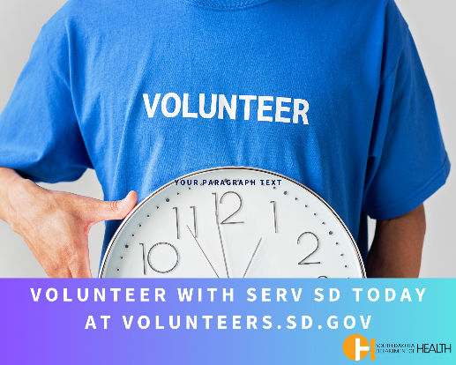

EDUCATION
Twitter | Facebook /LinkedIn | IMAGE
POD FACTS  Points of Dispensing (POD) sites save lives during a healthcare crisis. To learn more about PODs visit the South Dakota Department of Health POD Toolkit at https://doh.sd.gov/health-care-professionals/public-health-preparedness-and-response/Points-of-dispensing-information-resources/pods-toolkit/.  #KnowtheFacts | POD FACTS  Points of Dispensing (POD) sites located throughout the state provide communities with medications during a healthcare crisis such as a disease outbreak or bioterror attack.  For more information and education about PODs visit the South Dakota Department of Health POD Toolkit at https://doh.sd.gov/health-care-professionals/public-health-preparedness-and-response/Points-of-dispensing-information-resources/pods-toolkit/.  #KnowtheFacts | 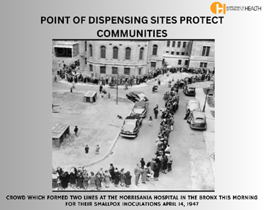
POD FACTS  Points of Dispensing (POD) sites save lives during a healthcare crisis. To learn more about PODs visit the South Dakota Department of Health POD Toolkit at https://doh.sd.gov/health-care-professionals/public-health-preparedness-and-response/Points-of-dispensing-information-resources/pods-toolkit/.  #KnowtheFacts | POD FACTS  Points of Dispensing (POD) sites located throughout the state provide communities with medications during a healthcare crisis such as a disease outbreak or bioterror attack.  For more information and education about PODs visit the South Dakota Department of Health POD Toolkit at https://doh.sd.gov/health-care-professionals/public-health-preparedness-and-response/Points-of-dispensing-information-resources/pods-toolkit/.  #KnowtheFacts | 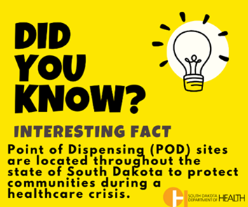

RECRUITMENT
Twitter |  | Facebook/LinkedIn | IMAGE
COMMUNITY HEROES!  Points of Dispensing (POD) sites protect communities during a healthcare crisis. Learn how you can be a community hero! Visit the South Dakota Department of Health POD Toolkit at https://doh.sd.gov/health-care-professionals/public-health-preparedness-and-response/Points-of-dispensing-information-resources/pods-toolkit/  #CommunityHero |  | COMMUNITY HEROES!  Points of Dispensing (POD) sites located throughout the state protect communities during a healthcare crisis such as a disease outbreak or bioterror attack. Volunteers receive training to learn how to respond to these emergencies.  Learn how you can be a community hero! For information and education about PODs visit the South Dakota Department of Health POD Toolkit at https://doh.sd.gov/health-care-professionals/public-health-preparedness-and-response/Points-of-dispensing-information-resources/pods-toolkit/  #CommunityHero | 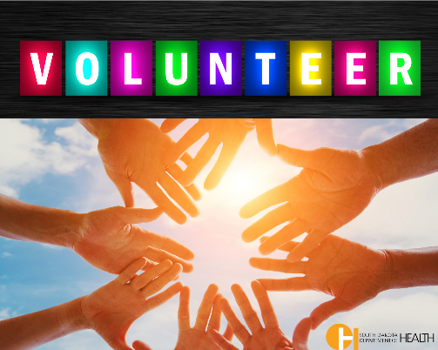
COMMUNITY HEROES!  Points of Dispensing (POD) sites protect communities during a healthcare crisis. Learn how you can be a community hero! Visit the South Dakota Department of Health POD Toolkit at https://doh.sd.gov/health-care-professionals/public-health-preparedness-and-response/Points-of-dispensing-information-resources/pods-toolkit/  #CommunityHero |  | COMMUNITY HEROES!  Points of Dispensing (POD) sites located throughout the state protect communities during a healthcare crisis such as a disease outbreak or bioterror attack. Volunteers receive training to learn how to respond to these emergencies.  Learn how you can be a community hero! For information and education about PODs visit the South Dakota Department of Health POD Toolkit at https://doh.sd.gov/health-care-professionals/public-health-preparedness-and-response/Points-of-dispensing-information-resources/pods-toolkit/  #CommunityHero | 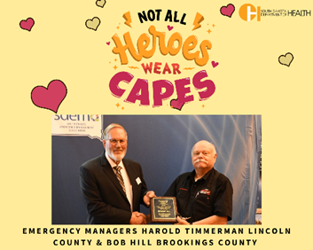
 | RECRUITMENT – Volunteer Recognition Day April 20th
 | Twitter | Facebook/LinkedIn | IMAGE
 | VOLUNTEER RECOGNITION  Thank a volunteer today!  Points of Dispensing (POD) sites protect communities if a healthcare crisis occurs. POD Volunteers are community champions that protect your community. Learn more about PODs at https://doh.sd.gov/health-care-professionals/public-health-preparedness-and-response/Points-of-dispensing-information-resources/.  Volunteer today at https://volunteers.sd.gov/index.php  #VOLUNTEER | VOLUNTEER RECOGNITION  Thank a volunteer today!  Points of Dispensing (POD) sites throughout the state are prepared to protect communities in a healthcare crisis such as a disease outbreak or bioterror attack by providing medications to prevent illness or loss of life. POD Volunteers are community champions that protect your community.  Learn more about PODs at https://doh.sd.gov/health-care-professionals/public-health-preparedness-and-response/Points-of-dispensing-information-resources/.  Volunteer today at https://volunteers.sd.gov/index.php !  #VOLUNTEER | 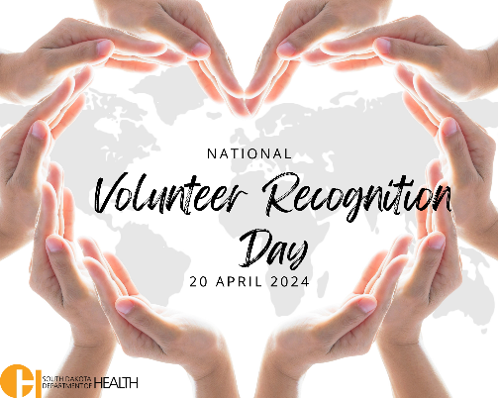
 | VOLUNTEER RECOGNITION  Thank a volunteer today!  Points of Dispensing (POD) sites protect communities if a healthcare crisis occurs. POD Volunteers are community champions that protect your community. Learn more about PODs at https://doh.sd.gov/health-care-professionals/public-health-preparedness-and-response/Points-of-dispensing-information-resources/.  Volunteer today at https://volunteers.sd.gov/index.php.  #VOLUNTEER | VOLUNTEER RECOGNITION  Thank a volunteer today!  Points of Dispensing (POD) sites throughout the state are prepared to protect communities in a healthcare crisis such as a disease outbreak or bioterror attack by providing medications to prevent illness or loss of life. POD Volunteers are community champions that protect your community.  Learn more about PODs at https://doh.sd.gov/health-care-professionals/public-health-preparedness-and-response/Points-of-dispensing-information-resources/.  Volunteer today at https://volunteers.sd.gov/index.php.  #VOLUNTEER | 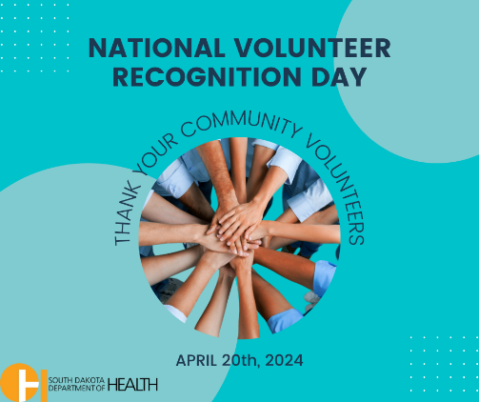

 | RECRUITMENT
 | Twitter | Facebook/LinkedIn |  | IMAGE
 | HEROES NEEDED!  How can you help protect your community during a healthcare emergency? Become a Points of Dispensing (POD) Volunteer today!  Learn more about PODs at https://doh.sd.gov/health-care-professionals/public-health-preparedness-and-response/Points-of-dispensing-information-resources/. Volunteer with SERV SD today at https://volunteers.sd.gov/index.php.  #Volunteer | HEROES NEEDED!  How can YOU help protect your community during a healthcare emergency such as a disease outbreak or bioterror attack? Become a volunteer for your community Points of Dispensing (POD) site. Brookings County Emergency Manager, Bob Hill ,says, “Providing assistance to those who need it is the most rewarding part of the job. My ‘day’ job mimics my volunteer work with the PPCC/POD.” Learn more about PODs at https://doh.sd.gov/health-care-professionals/public-health-preparedness-and-response/Points-of-dispensing-information-resources/. Volunteer with SERV SD today at https://volunteers.sd.gov/index.php  #Volunteer |  | 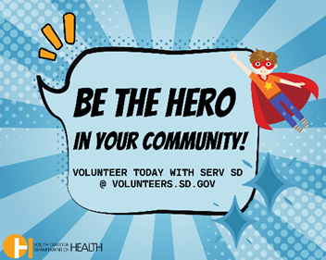
 | HEROES NEEDED!  How can you help protect your community during a healthcare emergency? Become a Points of Dispensing (POD) Volunteer today!  Learn more about PODs at https://doh.sd.gov/health-care-professionals/public-health-preparedness-and-response/Points-of-dispensing-information-resources/. Volunteer with SERV SD today at https://volunteers.sd.gov/index.php.  #Volunteer | HEROES NEEDED!  How can YOU help protect your community during a healthcare emergency such as a disease outbreak or bioterror attack? Become a volunteer for your community Points of Dispensing (POD) site. Brookings County Emergency Manager, Bob Hill ,says, “Providing assistance to those who need it is the most rewarding part of the job. My ‘day’ job mimics my volunteer work with the PPCC/POD.” Learn more about PODS at https://doh.sd.gov/health-care-professionals/public-health-preparedness-and-response/Points-of-dispensing-information-resources/. Volunteer with SERV SD today at https://volunteers.sd.gov/index.php.  #Volunteer |  | 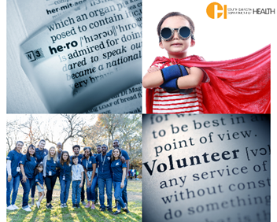
RECRUITMENT
Twitter |  | Facebook/LinkedIn |  | IMAGE
 | STRENGTH IN NUMBERS  Points of Dispensing (POD) sites protect communities if a healthcare crisis occurs and need community champions to volunteer.  Learn more about PODs at https://doh.sd.gov/health-care-professionals/public-health-preparedness-and-response/Points-of-dispensing-information-resources/. Volunteer with SERV SD today at https://volunteers.sd.gov/index.php.  #ReadyTogether | STRENGTH IN NUMBERS  Points of Dispensing (POD) sites throughout the state are prepared to protect communities in a healthcare crisis such as a disease outbreak or bioterror attack by providing medications to prevent illness or loss of life. POD sites need community champions to volunteer. Todd Mellette POD volunteer, Andrea Hacker says, “The benefit of being a POD volunteer is the knowing that you have your community taken care of if and when the POD is needed.” Learn more about PODs at https://doh.sd.gov/health-care-professionals/public-health-preparedness-and-response/Points-of-dispensing-information-resources/. Volunteer with SERV SD today at https://volunteers.sd.gov/index.php.  #ReadyTogether |  | 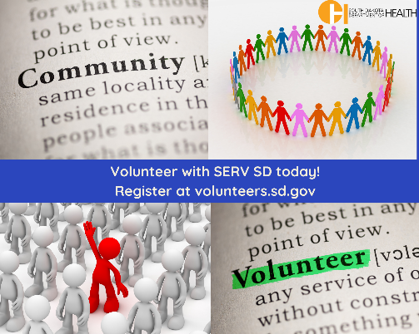
 | STRENGTH IN NUMBERS  Points of Dispensing (POD) sites protect communities if a healthcare crisis occurs and need community champions to volunteer.  Learn more about PODs at https://doh.sd.gov/health-care-professionals/public-health-preparedness-and-response/Points-of-dispensing-information-resources/. Volunteer with SERV SD today at https://volunteers.sd.gov/index.php.  #ReadyTogether | STRENGTH IN NUMBERS  Points of Dispensing (POD) sites throughout the state are prepared to protect communities in a healthcare crisis such as a disease outbreak or bioterror attack by providing medications to prevent illness or loss of life. POD sites need community champions to volunteer. Rosebud Sioux Tribe Emergency Manager, Andrea Hacker says, “The benefit of being a POD volunteer is the knowing that you have your community taken care of if and when the POD is needed.” Learn more about PODs at https://doh.sd.gov/health-care-professionals/public-health-preparedness-and-response/Points-of-dispensing-information-resources/.  Volunteer with SERV SD today at https://volunteers.sd.gov/index.php.  #ReadyTogether |  | 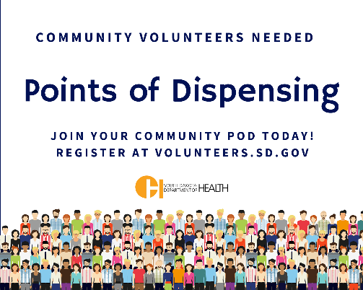
 | AWARENESS
 | Twitter |  | Facebook/LinkedIn | IMAGE
 | IS YOUR COMMUNITY PREPARED?  Preparedness during a healthcare emergency plays an essential role in keeping communities safe. Points of Dispensing (POD) sites help keep communities. To learn more about PODs visit the South Dakota Department of Health at https://doh.sd.gov/health-care-professionals/public-health-preparedness-and-response/Points-of-dispensing-information-resources/. Register with SERV SD at https://volunteers.sd.gov/index.php to volunteer today!  #Preparedness |  | IS YOUR COMMUNITY PREPARED?  Preparedness during a healthcare emergency such as a disease outbreak or bioterror attack plays an essential role in keeping communities safe. Points of Dispensing (POD) sites help keep communities protected during a healthcare emergency. POD Volunteer, Kevin O’Kelley, says the benefits of a POD is “Knowing that in the event of an emergency we will not panic, because we have practiced.” For information, education and training about PODs visit the South Dakota Department of Health at https://doh.sd.gov/health-care-professionals/public-health-preparedness-and-response/Points-of-dispensing-information-resources/. Register with SERV SD at https://volunteers.sd.gov/index.php to volunteer today!  #Preparedness | 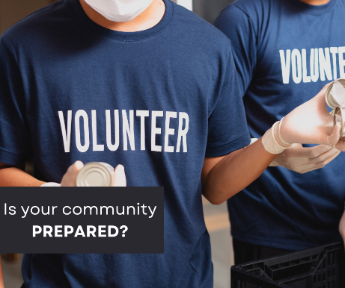
 | IS YOUR COMMUNITY PREPARED?  Preparedness during a healthcare emergency plays an essential role in keeping communities safe. Points of Dispensing (POD) sites help keep communities protected. To learn more about PODs visit the South Dakota Department of Health at https://doh.sd.gov/health-care-professionals/public-health-preparedness-and-response/Points-of-dispensing-information-resources/. Register with SERV SD at https://volunteers.sd.gov/index.php to volunteer today!  #Preparedness |  | IS YOUR COMMUNITY PREPARED?  Preparedness during a healthcare emergency such as a disease outbreak or bioterror attack plays an essential role in keeping communities safe. Points of Dispensing (POD) sites help keep communities protected during a healthcare emergency. POD Volunteer, Kevin O’Kelley, says the benefits of a POD is “Knowing that in the event of an emergency we will not panic, because we have practiced.” For information, education and training about PODs visit the South Dakota Department of Health at https://doh.sd.gov/health-care-professionals/public-health-preparedness-and-response/Points-of-dispensing-information-resources/. Register with SERV SD at https://volunteers.sd.gov/index.php to volunteer today!  #Preparedness | 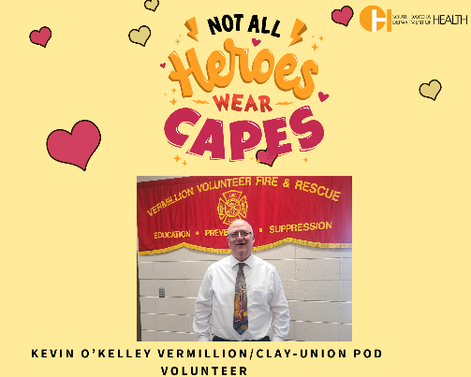
AWARENESS
Twitter |  |  | Facebook/LinkedIn |  | IMAGE
WHAT IS A POD?  Points of Dispensing (POD) sites are prepared to protect communities in a healthcare crisis like a disease outbreak or bioterror attack. Learn more about PODs at https://doh.sd.gov/health-care-professionals/public-health-preparedness-and-response/Points-of-dispensing-information-resources/.  #EmergencyPreparedness |  |  | WHAT IS A POD?  Points of Dispensing (POD) sites throughout the state are prepared to protect communities in a healthcare crisis such as a disease outbreak or bioterror attack. Community preparedness plays a critical role in protecting your community. Rosebud Sioux Tribe Emergency Manager, Andrea Hacker, believes, “PODs are important to each community, especially in these times when the country is under significant terror threats.” Learn more about PODs at https://doh.sd.gov/health-care-professionals/public-health-preparedness-and-response/Points-of-dispensing-information-resources/.  #EmergencyPreparedness |  | 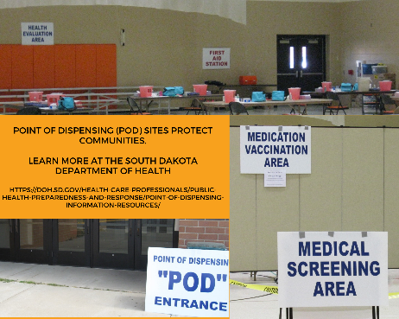
WHAT IS A POD?  Points of Dispensing (POD) sites are prepared to protect communities in a healthcare crisis like a disease outbreak or bioterror attack. Learn more about PODs at https://doh.sd.gov/health-care-professionals/public-health-preparedness-and-response/Points-of-dispensing-information-resources/.  #EmergencyPreparedness |  |  | WHAT IS A POD?  Points of Dispensing (POD) sites throughout the state are prepared to protect communities in a healthcare crisis such as a disease outbreak or bioterror attack. Community preparedness plays a critical role in protecting your community. Todd Mellette POD volunteer, Andrea Hacker, believes, “PODs are important to each community, especially in these times when the country is under significant terror threats.” Learn more about PODs at https://doh.sd.gov/health-care-professionals/public-health-preparedness-and-response/Points-of-dispensing-information-resources/.  #EmergencyPreparedness |  | 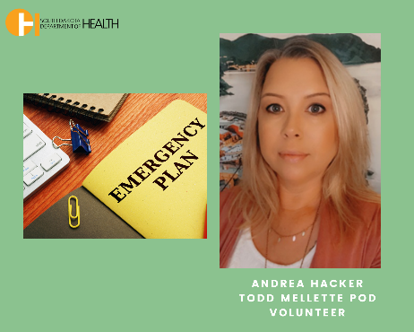

AWARENESS – National Preparedness Month September
Twitter | Facebook/LinkedIn | IMAGE
NATIONAL PREPAREDNESS MONTH  Is your community prepared? If a healthcare emergency or disease outbreak occurred today, what would YOU do?  Points of Dispensing (POD) sites throughout the state prepare for these types of emergencies. Learn more about PODs at https://doh.sd.gov/health-care-professionals/public-health-preparedness-and-response/Points-of-dispensing-information-resources/  #BePrepared | NATIONAL PREPAREDNESS MONTH  Is your community prepared? If a healthcare emergency or disease outbreak occurred today, what would YOU do?  Points of Dispensing (POD) sites throughout the state prepare for these types of emergencies. Learn more about PODs at https://doh.sd.gov/health-care-professionals/public-health-preparedness-and-response/Points-of-dispensing-information-resources/  #BePrepared | 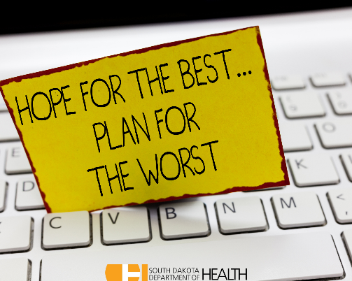
NATIONAL PREPAREDNESS MONTH  Is your community prepared? If a healthcare emergency or disease outbreak occurred today, what would YOU do?  Points of Dispensing (POD) sites throughout the state prepare for these types of emergencies. Learn more about PODs at https://doh.sd.gov/health-care-professionals/public-health-preparedness-and-response/Points-of-dispensing-information-resources/  #BePrepared | NATIONAL PREPAREDNESS MONTH  Is your community prepared? If a healthcare emergency or disease outbreak occurred today, what would YOU do?  Points of Dispensing (POD) sites throughout the state prepare for these types of emergencies. Learn more about PODs at https://doh.sd.gov/health-care-professionals/public-health-preparedness-and-response/Points-of-dispensing-information-resources/  #BePrepared | 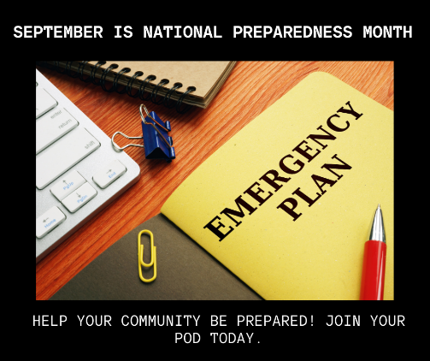

AWARENESS
Twitter | Facebook/LinkedIn | IMAGE
ARE YOU READY?  Did you know Points of Dispensing (POD) sites protect communities?  If a healthcare emergency such as a disease outbreak or bioterror attack occurred today, would you be ready? PODs prepare for these types of emergencies.  Learn more about PODs at https://doh.sd.gov/health-care-professionals/public-health-preparedness-and-response/Points-of-dispensing-information-resources/  #ReadyForAnything | ARE YOU READY?  Did you know Points of Dispensing (POD) sites throughout the state protect communities?  If a healthcare emergency such as a disease outbreak or bioterror attack occurred today, would you be ready? PODs prepare for these types of emergencies.  Learn more about PODs at https://doh.sd.gov/health-care-professionals/public-health-preparedness-and-response/Points-of-dispensing-information-resources/  #ReadyForAnything | 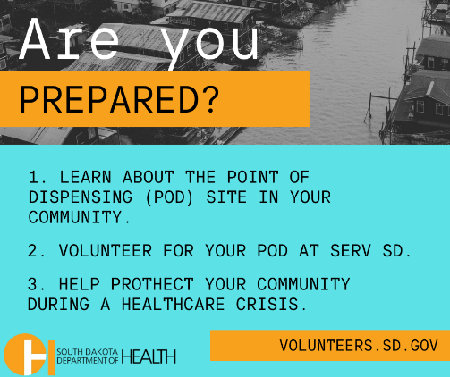
ARE YOU READY?  Did you know Points of Dispensing (POD) sites protect communities?  If a healthcare emergency such as a disease outbreak or bioterror attack occurred today, would you be ready? PODs prepare for these types of emergencies.  Learn more about PODs at https://doh.sd.gov/health-care-professionals/public-health-preparedness-and-response/Points-of-dispensing-information-resources/  #ReadyForAnything | ARE YOU READY?  Did you know Points of Dispensing (POD) sites throughout the state protect communities?  If a healthcare emergency such as a disease outbreak or bioterror attack occurred today, would you be ready? PODs prepare for these types of emergencies.  Learn more about PODs at https://doh.sd.gov/health-care-professionals/public-health-preparedness-and-response/Points-of-dispensing-information-resources/  #ReadyForAnything | 