[Organization logo] 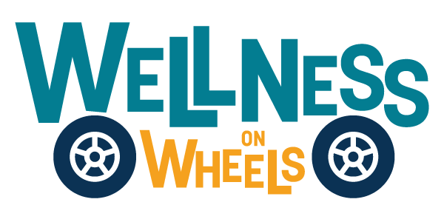

**For Immediate Release:** [Month Day, Year]

**Contact:** [Additional Contact Name and Email]

**[Organization name] to Host Wellness on Wheels (WOW) Van Event**

[COMMUNITY], SD – The Wellness on Wheels (WOW) van will be providing vital health services at [location/business name and address] on [date-month, day, year] from [time]. These events aim to deliver accessible healthcare services to underserved communities and [occur on the second Tuesday of every month]. (edit to reflect what is applicable to your location/event)

Services available at the WOW van include: (Please edit as needed based on the services available at event)

* Women, Infants, and Children (WIC);
* Pregnancy Care;
* Immunizations;
* Oral Health;
* Safe Sleep Education;
* Maternal Depression Screening;
* Developmental Screening; and
* Sexually Transmitted Infection (STI) Testing.

[Replace quote **OR** use the following] “Through initiatives like the Wellness on Wheels van, we’re making it easier for people in South Dakota to access essential healthcare services,” said [Name of Local Representative]. “By bringing care to the community, we aim to address barriers like transportation and provide tailored solutions for public health needs.”

The Wellness on Wheels (WOW) program is an innovative initiative by the South Dakota Department of Health. The WOW van offers a range of critical services to address the diverse healthcare needs of South Dakotans, particularly those facing socioeconomic barriers.

Through collaboration with community organizations, healthcare providers, and social service agencies, the WOW van brings healthcare directly to individuals where they live and work. The program also enhances referrals, improves care coordination, and addresses gaps in services, fostering better health outcomes statewide.

For more information about the Wellness on Wheels program, visit <https://doh.sd.gov/programs/wellness-on-wheels/>.

###