Security Assessment & Planning Guidelines
- Keeping POD staff and the public safe and supplies secure at each POD will be a primary objective.
- Local Law Enforcement should be involved in the SNS Mass Dispensing planning process.

Additional information on security related to SNS can be found at Receiving, distributing, and dispensing Strategic National Stockpile assets : guide to preparedness, Version 11
- Each individual POD location must have a completed security assessment and written plan.
  - The assessment and resulting plan should address the following:
    - Potential risk areas (e.g. Large number of access points to PODs)
    - Analysis of the surrounding area (e.g., providing adequate onsite or nearby parking near high-flow streets or freeways).
    - Specific physical security measures to effectively safeguard personnel at the dispensing facility
    - Security measures to mitigate risk (e.g., reducing the number of access points to the POD)
    - POD queuing and clinic layout (e.g., allowing a controlled patient flow)
    - Procedures for managing disorderly persons or crowds, foot traffic into and out of the facility,
    - Incoming vehicular traffic, parking, and outgoing traffic
    - Number of security-support team members needed per shift for the POD
    - Communications resources and plans for security team members
    - Security management structure (chain of command)
  - The following items must be included in the SNS plan based on requirements in the DSNS Local Technical Assistance Review Tool – October 2007:
    - Local level position identified to plan/coordinate the overall security for the Points of Dispensing
      - Security Coordinator has been trained regarding SNS activities and Mass Dispensing
      - Local security/law enforcement agencies identified and oriented for POD operations
      - Contact information for security coordinator and identified security support agencies
    - Security plans for transportation of SNS medical materiel have been developed
      - Escort plans for materiel transported from the RSS (if applicable)
      - Escort plans for materiel transported from one POD to another
      - Escort plans for personnel and the public using mass transit to and from the PODs
    - Security plans for the individual PODs
      - Security and vulnerability assessment of the location and facility (strengths & weaknesses)
      - Interior physical security of the location
        - Security sweep conducted immediately prior to use by POD staff
        - Establish posts for law enforcement officers
        - Access control to specific locations within the facility (e.g. staff-only areas, supply area)
        - Crowd control within the facility
      - Exterior physical security of the location
        - Specialized unit needs (e.g. traffic, tactical, canine, etc.)
        - Additional physical barriers (needs and source)
        - POD staff parking and check-in areas
        - Vehicular Ingress & Egress control
        - Crowd control surrounding facility
        - Access control to facility
      - Security management plan provides for:
        - Law enforcement command center
        - Communication and coordination between law enforcement and other participating agencies
        - Radio channels determined
        - Shifts established
        - Sufficient officers assigned
      - Evacuation plans established
      - Security breach contingency plans
    - Identification procedures (e.g. badges, vehicle placards) are in place for all personnel reporting to work at the POD.
      - Vehicle placards to allow access to restricted parking areas
      - Individual ID badges should include: photo, name, role, access level, verified credentials or training level
      - System for handling spontaneous volunteers at the POD
    - Site-specific details for each POD have been included in the security plans.
- Recognize that these written plans are likely to be considered secure/confidential documents by the law enforcement agency writing them. The SNS plan should include information on the following:
  - The law enforcement agencies that have jurisdiction within the area covered by the plan
  - Facility and Security Points of Contact for each POD
  - Generalized pertinent information related to area law enforcement’s standard operating procedures

County Date
POD Site Evaluation & Planning Checklist
Person completing form: Contact #
Facility Name: MOU in place?
YES NO
Street Address:
City and zip code:
Site Characteristics (include who owns the building, private/state/local, type of facility, etc.):

Facility Contact Person(s) & Title(s)
Primary Contact – During Business Hours:
Name/Title:
Work Phone:
Cell Phone:
Pager:
Email:

Alternate Contact – During Business Hours:
Name/Title:
Work Phone:
Cell Phone:
Pager:
Email:

Primary After-Hours Contact – 24/7 Emergency:
Name/Title:
Work Phone:
Cell Phone:
Pager:
Home Phone:
Email:

Alternate After-Hours Contact – 24/7 Emergency:
Name/Title:
Work Phone:
Cell Phone:
Pager:
Home Phone:
Email:

General Site Information
Estimated facility size (square feet)
Number of usable rooms
Is the site available 24/7?  If “No”, what are the restrictions? |  |  | Yes |  | No
Are there multiple levels (steps between rooms/multiple floors) in the space to be utilized for operations?  If yes, are elevators available? |  |  | Yes  Yes |  | No  No
Do the roads leading to the site allow for easy access? |  |  | Yes |  | No
Has the facility been designated for other functions during an emergency?  If “Yes”, explain: |  |  | Yes |  | No
Is the site located in a flood prone area? |  |  | Yes |  | No
Is the facility and surrounding environment free of hazardous materials and chemical, biological, and mechanical hazards? |  |  | Yes |  | No
Name of closest law enforcement agency:
Address:
Approximate number of miles location from site:
Name of closest medical facility/hospital:
Address:
Approximate number of miles location from site:
General Comments about the site:
Facility Exterior/Interior Information
**Aerial photos and/or layout diagrams of the site, including surrounding access roads and proposed traffic patterns, parking, foot traffic, etc. may be included with the completed checklist.
Number of external entrances/exit door to site
Estimated number of parking spaces at site
Ancillary parking in close proximity?  If “Yes”, number of miles to ancillary location: |  |  | Yes |  | No
Is there staff parking, separate from the general public? |  |  | Yes |  | No
Is there standoff between parking and the POD site? |  |  | Yes |  | No
Will there be a need for vehicular traffic control to the POD site? |  |  | Yes |  | No
Are other physical barriers/access control measures needed outside? |  |  | Yes |  | No
Is there adequate exterior lighting around the building perimeter? |  |  | Yes |  | No
Is the parking area well lit? |  |  | Yes |  | No
Is there sufficient interior lighting? |  |  | Yes |  | No
Is there CCTV or some type of video monitoring for the interior/exterior? |  |  | Yes |  | No
Is a large waiting/assembly area(s) available? |  |  | Yes |  | No
Will foot traffic easily flow from outside to inside to back outside? |  |  | Yes |  | No
Are other physical barriers/access control measures needed inside? |  |  | Yes |  | No
Is there secure storage area for receipt/storage of medical supplies? |  |  | Yes |  | No
Other exterior notes:
Other interior notes:
Security Planning
Have escort security plans been developed to the POD site? |  |  | Yes |  | No
Are POD security personnel part of the escort security plan? |  |  | Yes |  | No
Can personnel perform a security sweep prior to material arrival? |  |  | Yes |  | No
Can the site be secured/access controlled? |  |  | Yes |  | No
Are security personnel necessary on both exterior and interior? |  |  | Yes |  | No
Will there be assigned, static security posts? |  |  | Yes |  | No
Will there be assigned, roving security posts? |  |  | Yes |  | No
Will there be a need for specialized units (canine, EOD, Tactical, Traffic, etc.)? |  |  | Yes |  | No
Estimated minimum number of required security personnel for building interior?
Estimated minimal number of required security personnel for building exterior?
Are procedures in place to identify/badge POD staff (individuals & vehicles)? |  |  | Yes |  | No
Is there a plan for handling security breaches/disruptive personnel? |  |  | Yes |  | No
Is there an evacuation plan? |  |  | Yes |  | No
Is emergency lighting available? |  |  | Yes |  | No
Who holds and maintains the site security plans (agency)?
Agency Contact Name:
Phone Number(s):
Other Safety/Security notes:
Communications
Number of telephone land-lines?
What channel(s) and frequency will law enforcement operate on?
Is there adequate cellular phone reception inside the site? |  |  | Yes |  | No
Are public telephones available? |  |  | Yes |  | No
Is there a dedicated FAX machine on site? |  |  | Yes |  | No
Is Internet access available? |  |  | Yes |  | No
Is a Public Address (PA) System available at the site? |  |  | Yes |  | No
Will any of the following methods of communication be used?  Satellite phones?  HAM/Amateur radio?  UHF/VHF/800 MHz radios?  Bullhorns? |  |  | Yes  Yes  Yes  Yes  Yes |  | No  No  No  No  No
Other Communications notes:
Staffing
Have individuals been identified for set-up and the initial shift at this site, and have job action sheets been created? | Individuals Identified? |  |  | Job Action Sheet Created?
Security Unit Leader and Team Members | Yes | No |  | Yes | No
Runners and Assistants | Yes | No |  | Yes | No
Can law enforcement be available within 6-12 hours of notification? |  |  |  | Yes | No
Has law enforcement been identified for at least two operational periods (shifts)? |  |  |  | Yes | No
Will law enforcement receive Just-In-Time training at the site during an event? |  |  |  | Yes | No
Will there be a POD SOG or Operations Manual available at the POD? |  |  |  | Yes | No
Can law enforcement provide personnel 24 hours per day for several days? |  |  |  | Yes | No
Have shift schedules been developed for law enforcement personnel? |  |  |  | Yes | No
Will there be a site specific written security plan for this POD? |  |  |  | Yes | No
Who maintains the list of core POD staff members and contact info?
Name and contact information for person responsible for activating/notifying Security POD staff:
Name:
Phone # Back-up #
Other staffing notes:

Supplemental Information
Diagrams and Pictures:
Diagrams and/or plans of the POD layout should be included the SNS Mass Dispensing Plan.
Aerial photographs help with traffic flow, ingress, and egress planning.
Interior pictures and floor plans should be attached to the completed the checklist.
A proposed set-up and flow diagram for the dispensing clinics of each POD should also be provided.
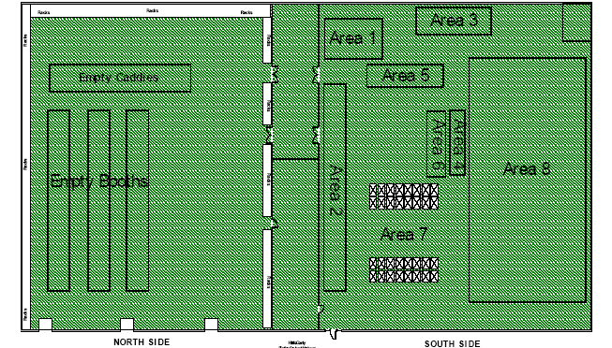
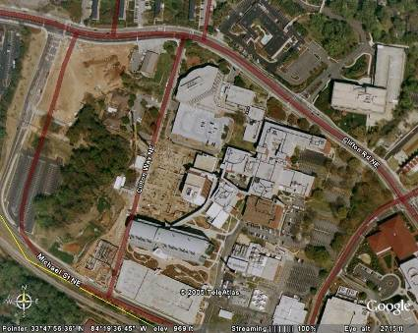
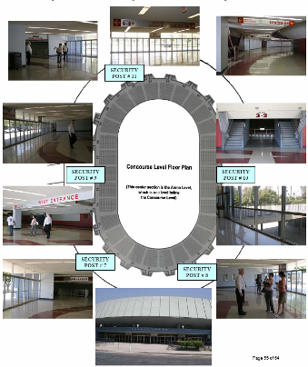
Examples:

