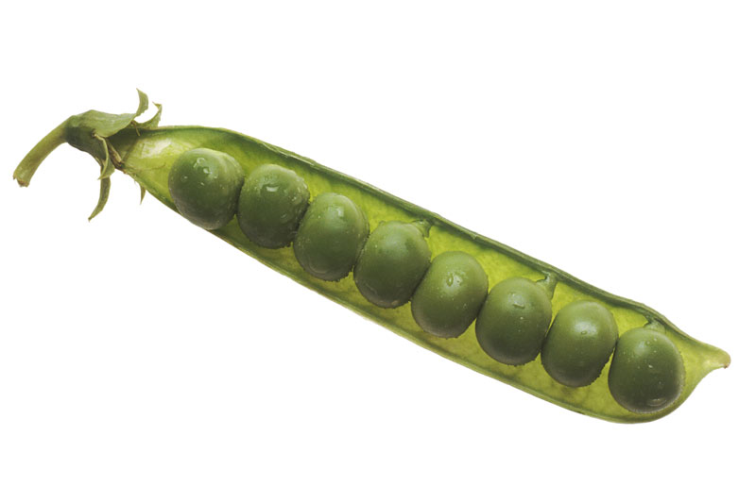

**South Dakota POD**

**Job Action Sheets**



