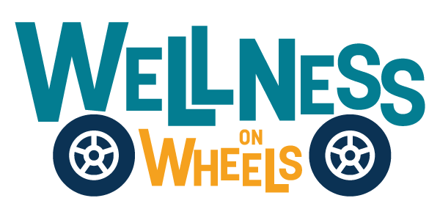

**Public Service Announcement**

The Wellness on Wheels (WOW) van is rolling into [location/business name] at [address] on [date-month, day, year] from [time]! Join us for vital health services, including WIC, pregnancy care, immunizations, oral health, STI testing, and more.

These events make healthcare more accessible to underserved communities across South Dakota. The WOW program, brought to you by the South Dakota Department of Health, bridges gaps in care.

Learn more at <https://doh.sd.gov/programs/wellness-on-wheels/>.